**MGMT 6962 Assignment 7**

**Name**: Yihui Yang **RIN**: 661979332

The data set I choose is Cervical Cancer Behavior Risk Data Set and Wine Quality Data Set.

1. Exploratory Data Analysis

First, take a look at cervical cancer behavior risk data. There are 19 variables in this data set.

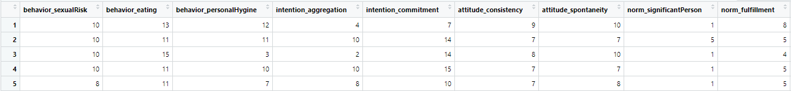

The first 18 columns are independent variables, which comes from 8 main variables including behavior, intention, attitude, norm, perception, motivation, social support and empowerment. The last columns is whether the this patient has cancer or not.

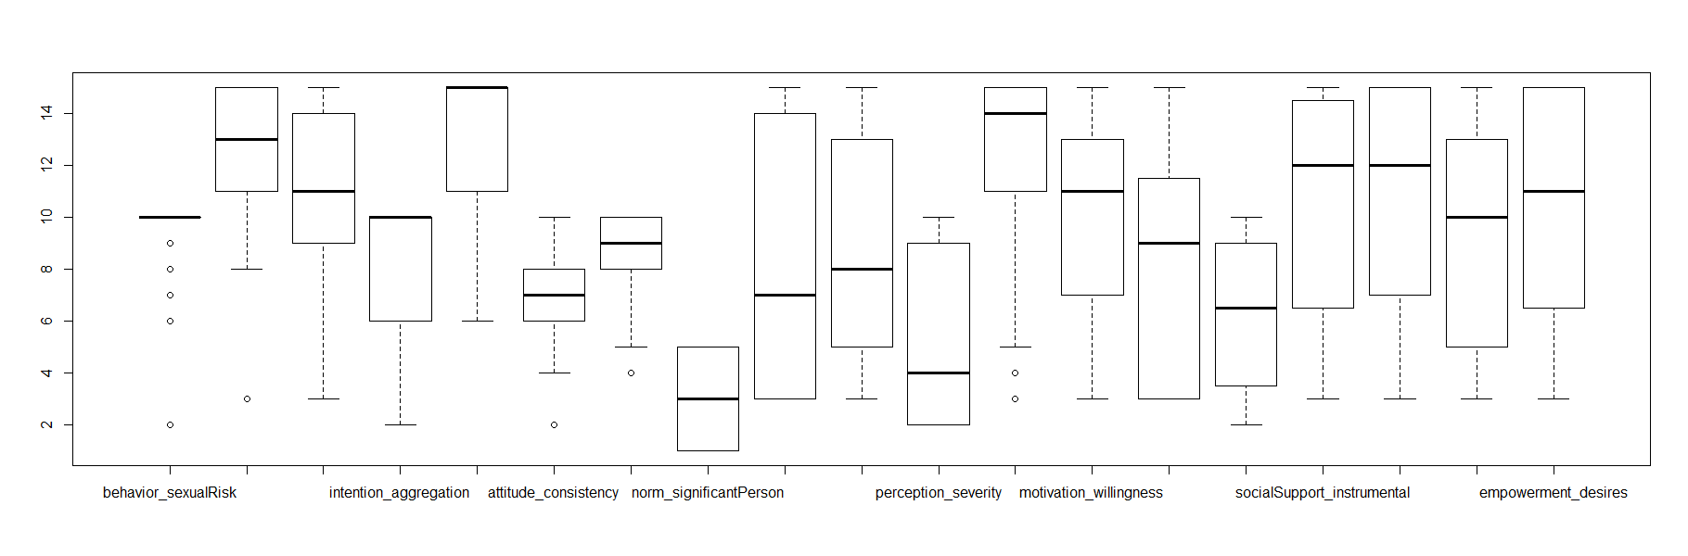

As the first 18 columns are numeric, I can plot the boxplot to check the distribution. Most of the ‘behavior_eating’ score is 10, but there are a few outliners.

From the graph above, we can conclude that most data located in the range from 2 to 14.

I used the correlation maps to find the relationship within the independent variables.

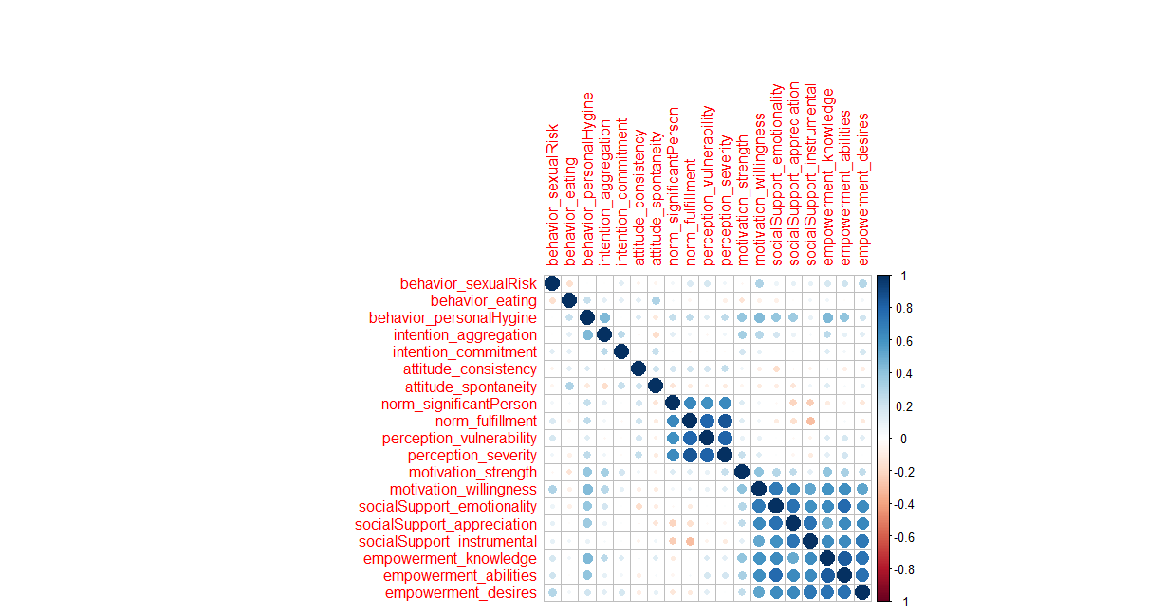

Behavior, intention and attitude demensions have no strong correlation with each other. Norm and perception have strong correlation with each other. Motivation, social support and empowerment have strong correlation with each other.

Then, take a look at the wine quality data. The wine quality data consist of red and white wine data.

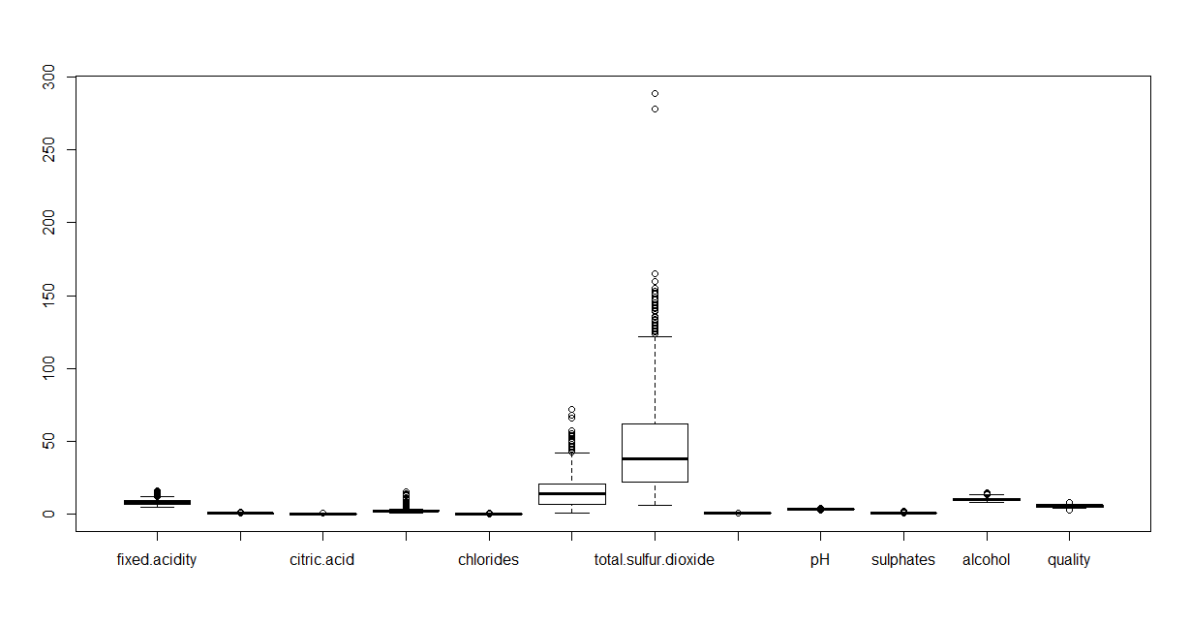red

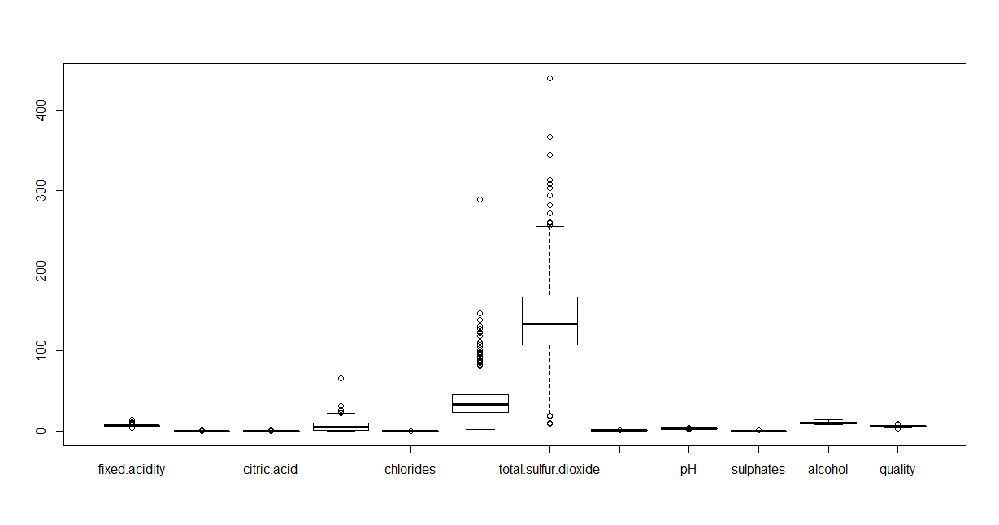

White

Both these data sets have same number of dimensions, but it seems that red and white wine have different scales. In the future models, I should conduct normalization method before modeling.

Also, red and white wine seem to have different characters. I will combine both the data set together and do some analysis after.

After combining them together, here is the distribution of quality.

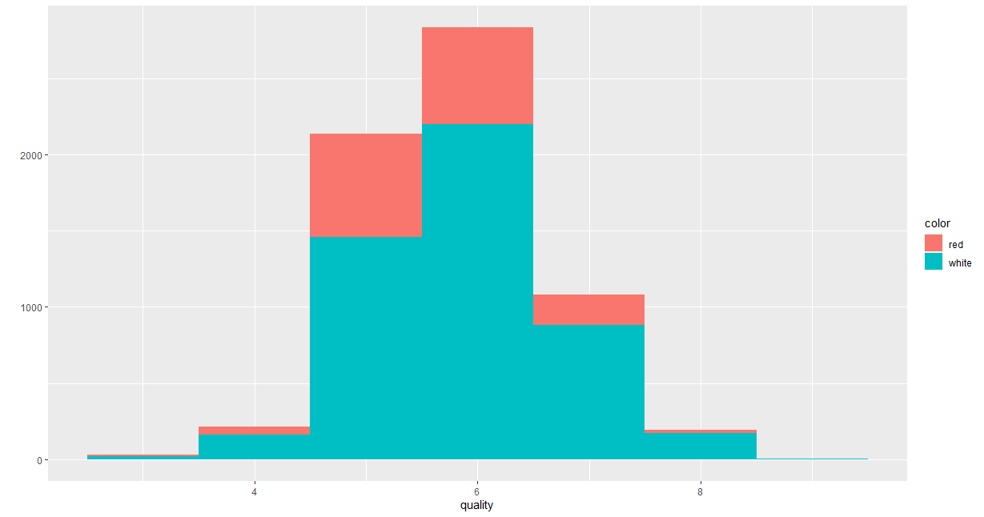

Here is the correlation map.

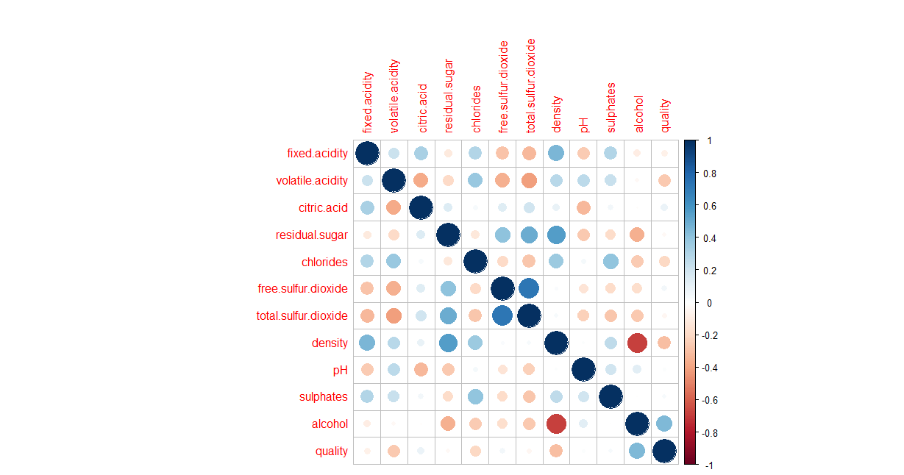

Free sulfur dioxide and total sulfur dioxide have strong correlation with each other.

1. Model Development

For Cervical Cancer Behavior Risk Data Set, I conduct 3 models.

1. Logistic regression

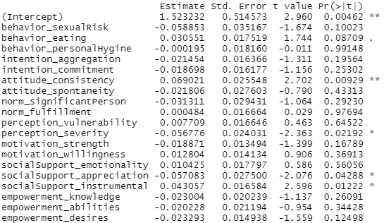

As we can see above, attitude_consistency, perception_serverity, and social support play a significant role in the model.

1. Random forest classification

For the random forest model, I got 88.89% overall accurate rate, which is good. The OOB estimate of error rate it 11.11%

1. SVM

For SVM, here is the summary of the model:

Here is the confusion matrix:



Overall, I got 94.44% accurate rate, which is better than the result given by the random forest model.

For wine quality data set, I also conduct 3 models.

1. Random forest

Overall accurate rate is 70.6%. Mistakes are very likely to happen when the quality is too high or too low.

1. KNN

The overall accurate rate is 45.96%. It seems that random forest performs better than this one. In this model, since the number of quality ‘3’ is quality low, the prediction result will miss this result.

1. Kmeans

First, I use elbow function to find the k number. Before that, I subset the data by filtering out the quality list because I want to compare the model result with this column and hope to draw some conclusion from it.

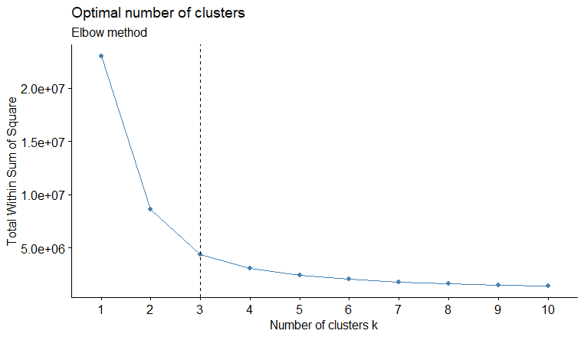

From the chart above, k equals to 3.

On the left, it is the cluster predicted by kmeans. On the bottom, it’s the quality of the wine.

For group one, majority of the records are from low quality to middle level quality.

For group two, most of the records are middle quality.

For group three, most of the records are high quality wine.

1. Decisions (3%)

For Cervical Cancer Behavior Risk Data Set, all independent data are numeric and within similar scale – from 4 to 20. Therefore, I can easily conduct classification model without normalization the data.



After comparing the models, the KNN model with accurate rate more than 90% outperform the rest of them.



For the wine data, I first combine two data sets together and plot correlation maps to see the relationship within the data.



The data within the same or similar categories have strong correlation.

I conduct several supervised models. At last, the random forest model beats the KNN by 70% accurate rate.

Meanwhile, I also conduct an unsupervised model and turned out to be interested.

The model results can clearly cluster the data into high quality, middle quality and low quality groups.